EIA IMPORTANT QUESTIONS

1. Classify the mitigation measures to prevent soil erosion for development project?

2. Examine the Steps for preparation of audit report?

3. Select any case study related to wildlife act?

4. Choose legislation objectives of environmental audit?

5. Explain brief about environmental protection act?

6. What is seismicity?

**Seismicity**, the worldwide or local distribution of earthquakes in space, time, and magnitude. More specifically, it refers to the measure of the frequency of earthquakes in a region—for example, the number of earthquakes of magnitude between 5 and 6 per 100 square km (39 square miles).

7. Write the short note soil quality?

**Soil quality** is a measure of the condition of [soil](https://en.wikipedia.org/wiki/Soil" \o "Soil) relative to the requirements of one or more biotic species and or to any [human](https://en.wikipedia.org/wiki/Human" \o "Human) need or purpose. According to the [United States Department of Agriculture](https://en.wikipedia.org/wiki/United_States_Department_of_Agriculture" \o "United States Department of Agriculture) [Natural Resources Conservation Service](https://en.wikipedia.org/wiki/Natural_Resources_Conservation_Service" \o "Natural Resources Conservation Service), "Soil quality is the capacity of a specific kind of soil to function, within natural or managed ecosystem boundaries, to sustain plant and animal productivity, maintain or enhance water and [air quality](https://en.wikipedia.org/wiki/Air_pollution" \o "Air pollution), and support human health and habitation. The [European Commission](https://en.wikipedia.org/wiki/European_Commission" \o "European Commission)'s [Joint Research Centre](https://en.wikipedia.org/wiki/Joint_Research_Centre" \o "Joint Research Centre) proposed a definition, stating that "Soil quality is an account of the soil's ability to provide ecosystem and social services through its capacities to perform its functions under changing conditions."

Soil quality reflects how well a soil performs the functions of maintaining [biodiversity](https://en.wikipedia.org/wiki/Biodiversity" \o "Biodiversity) and productivity, partitioning water and solute flow, filtering and buffering, [nutrient cycling](https://en.wikipedia.org/wiki/Nutrient_cycle" \o "Nutrient cycle), and providing support for plants and other structures. [Soil management](https://en.wikipedia.org/wiki/Soil_management" \o "Soil management) has a major impact on soil quality.

Soil quality in agricultural terms is measured on a scale of [soil value](https://en.wikipedia.org/wiki/Soil_value" \o "Soil value) (*Bodenwertzahl*) in [Germany](https://en.wikipedia.org/wiki/Germany" \o "Germany).

Soil quality relates to [soil functions](https://en.wikipedia.org/wiki/Soil_functions" \o "Soil functions). Unlike water or air, for which established standards have been set, soil quality is difficult to define or quantify. Soil quality can be evaluated using the Soil Management Assessment Framework

8. What you mean audit report?

The **auditor's report** is a formal opinion, or [disclaimer](https://en.wikipedia.org/wiki/Disclaimer" \o "Disclaimer) thereof, issued by either an [internal auditor](https://en.wikipedia.org/wiki/Internal_auditor" \o "Internal auditor) or an independent [external auditor](https://en.wikipedia.org/wiki/External_auditor" \o "External auditor) as a result of an internal or external [audit](https://en.wikipedia.org/wiki/Audit" \o "Audit), as an [assurance](https://en.wikipedia.org/wiki/Assurance_services" \o "Assurance services) service in order for the user to make decisions based on the results of the audit.

9. Explain Objectives of air act?

The fundamental objective of **[the Air Act, 1981](https://www.bnblegal.com/bareact/air-prevention-and-control-of-pollution-act-1981/)** is to provide clean air to the citizens and main objectives are:

a) It provides that the air pollution in any way be prevented and controlled. It also provides that air must be restored and maintained for future use.

b) It provides for the establishment of central and state boards for the prevention and control of air pollution.

c) It provides powers and functions to the board so constituted relating to matters of air pollution

d) To provide penalties for the contravention of the provisions of the air act.

e) It also provides for the establishment of Central and State level air testing labs so that the boards constituted may assess the extent of pollution.

10. When motor act passed? Any Objectives of motor act?

The Motor Vehicles Act, passed in the year 1988 by the Indian Parliament, regulates almost all aspects of road transport vehicles. It has provisions for traffic regulations, vehicle insurance, registration of motor vehicles, controlling permits and penalties. The Act came into force from 1 July 1989.

11. Summaries assessment of impact significance of soil?

12. Analyze Mitigation measure for Preventive soil erosion?

13. Classify Stages for preparation of audit report?

14. List of audits report explain briefly?

15. Explain the briefly functions of central pollution control board?

16. Select any case study related to Motor act?

17. What you mean delineation study aera?

18. list of audit reports?

The audit report is the report that contains the [audit’s opinion](https://www.wikiaccounting.com/audits-opinion-unmodified-unqualified-and-modifiedqualified-disclaimer-adverse/) which is issued by independence auditors after their examination on the [entity’s financial statements](https://www.wikiaccounting.com/five-types-of-financial-statements-ifrs/) and related reports. Unqualified Audit Report (Clean Audit Report), Qualified Audit Report, Disclaimer Audit Report, and Adverse Audit Report.

19. Simplify Any three steps of audit report filing?

20. Explain Objectives of Water act?

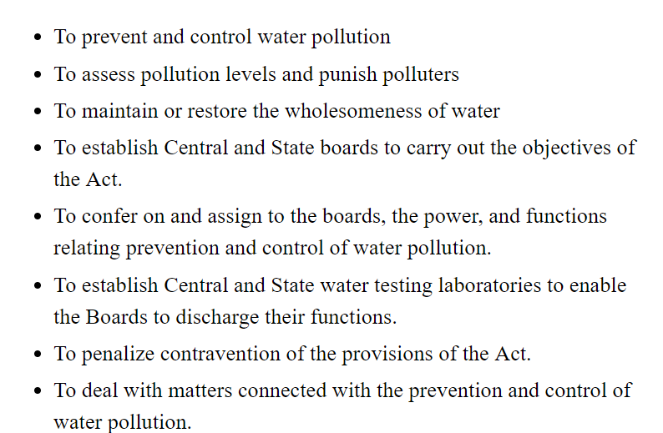

21. Functions of wild life control board?

22. Which method opted for soil remediations?